Day 05 Assignment 05

1> Creation of shell file $touch filename.sh

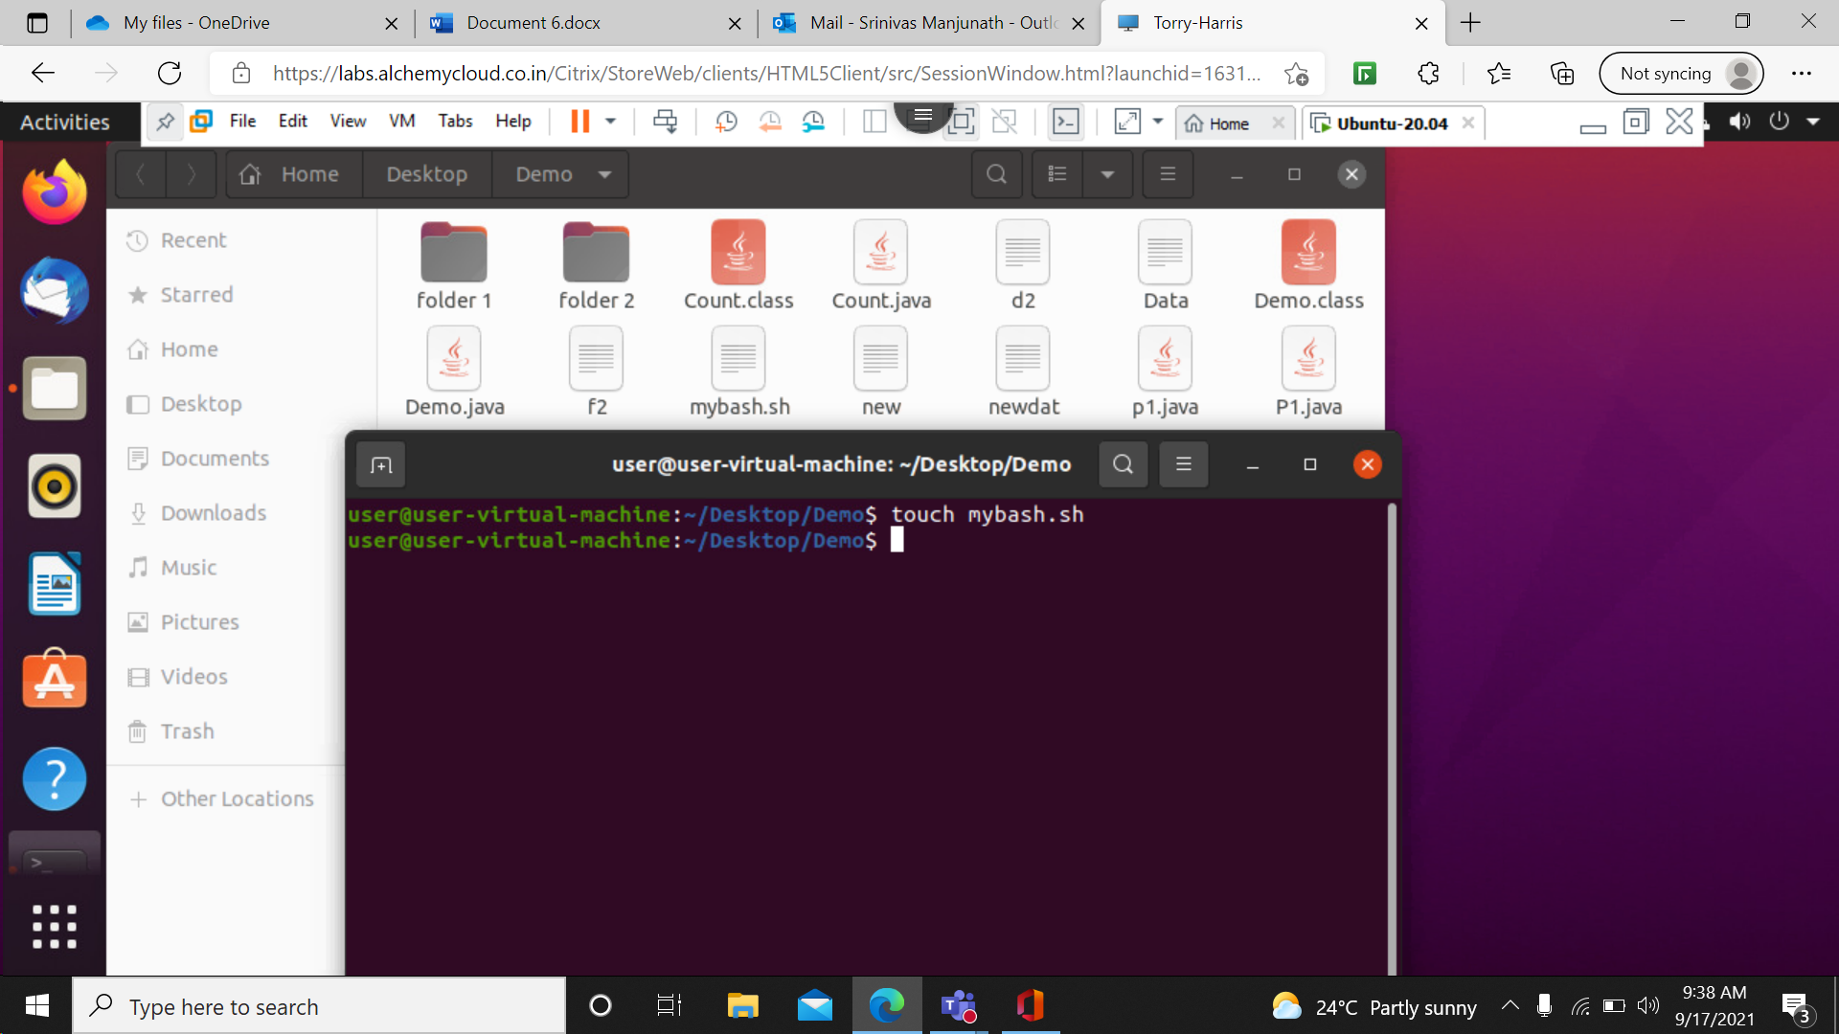

2>To open and display the data in shell file we can do it by cat command.

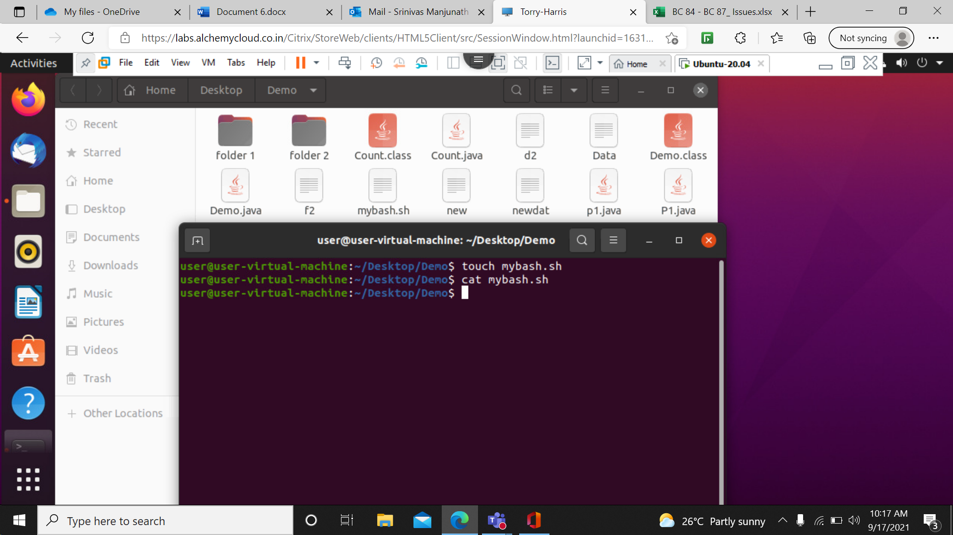

3> to edit we can use vim filename or use any text editor like nano also.

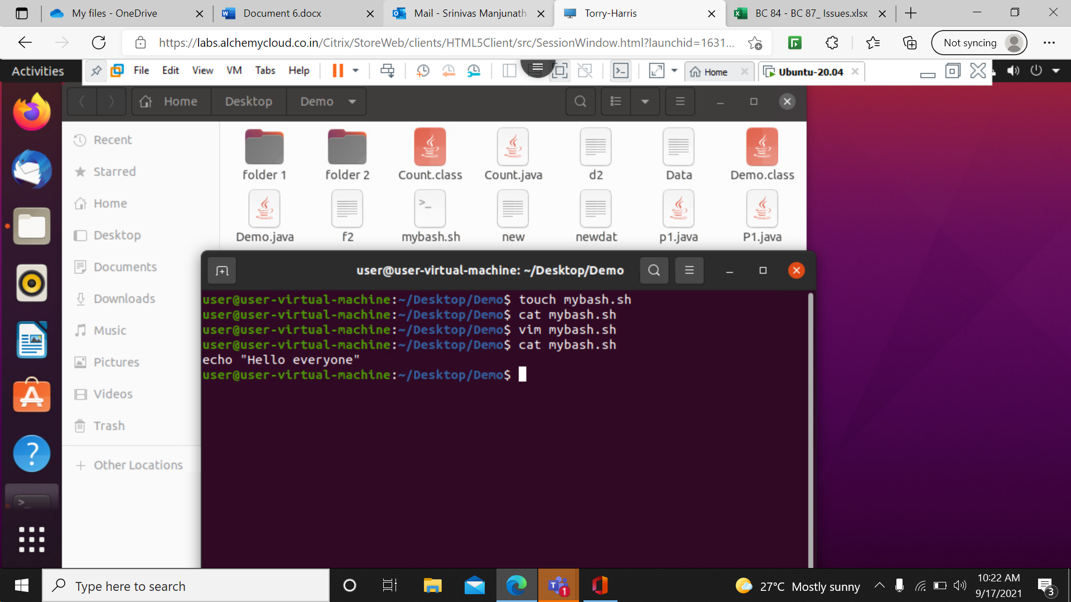

4> gedit is text editor used to create a file and also to open a file, if a file doesn't exist it will create it.

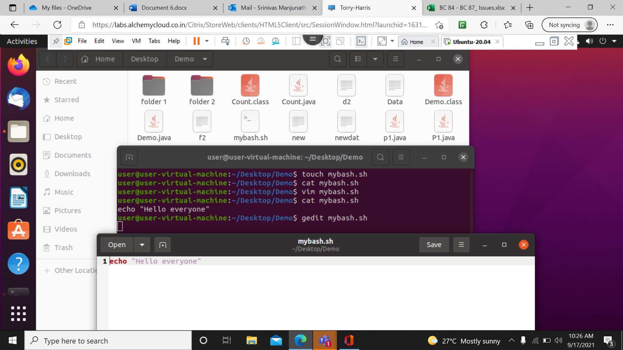

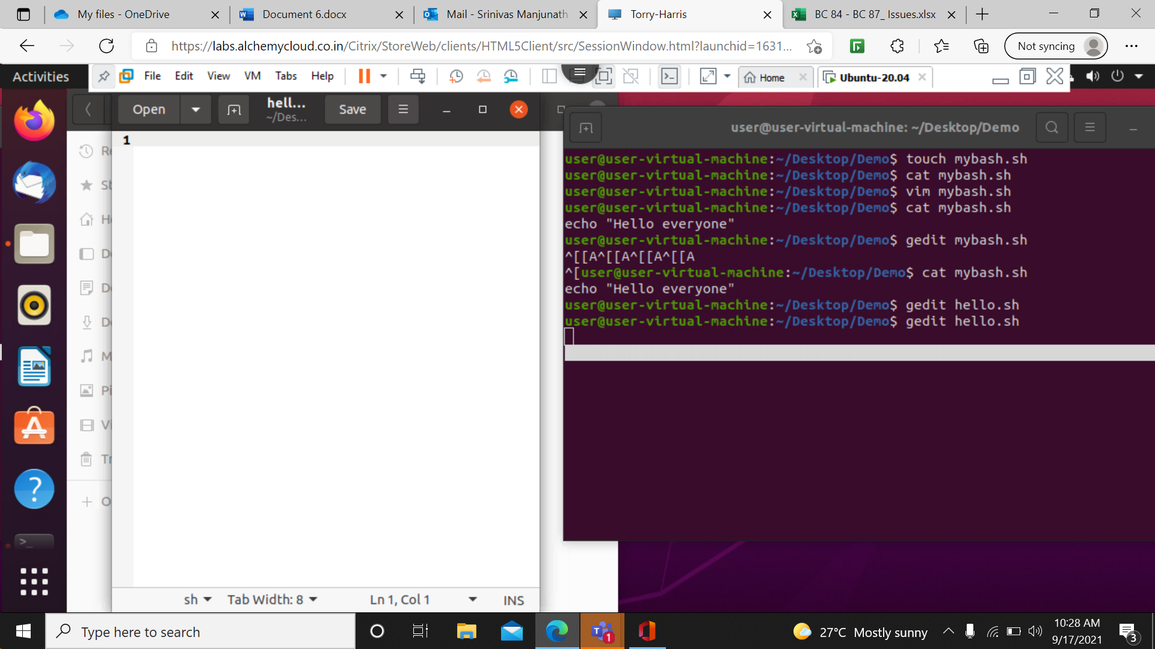

5> Creation of new file using $gedit command.

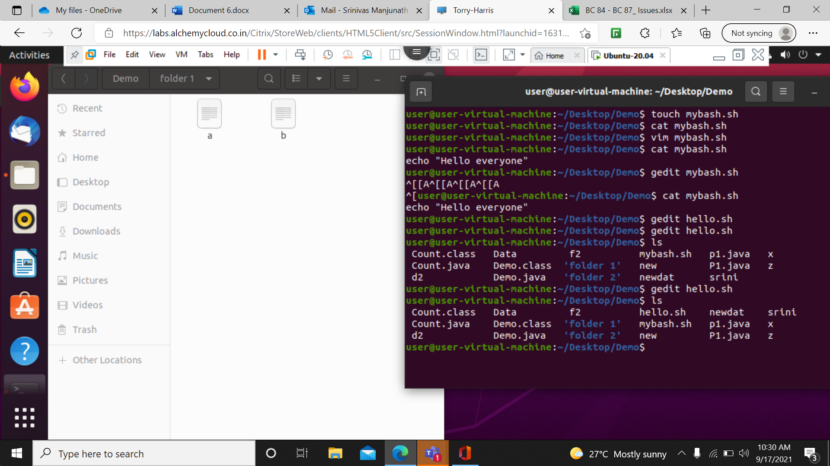

6> ./filename is used to execute the file.

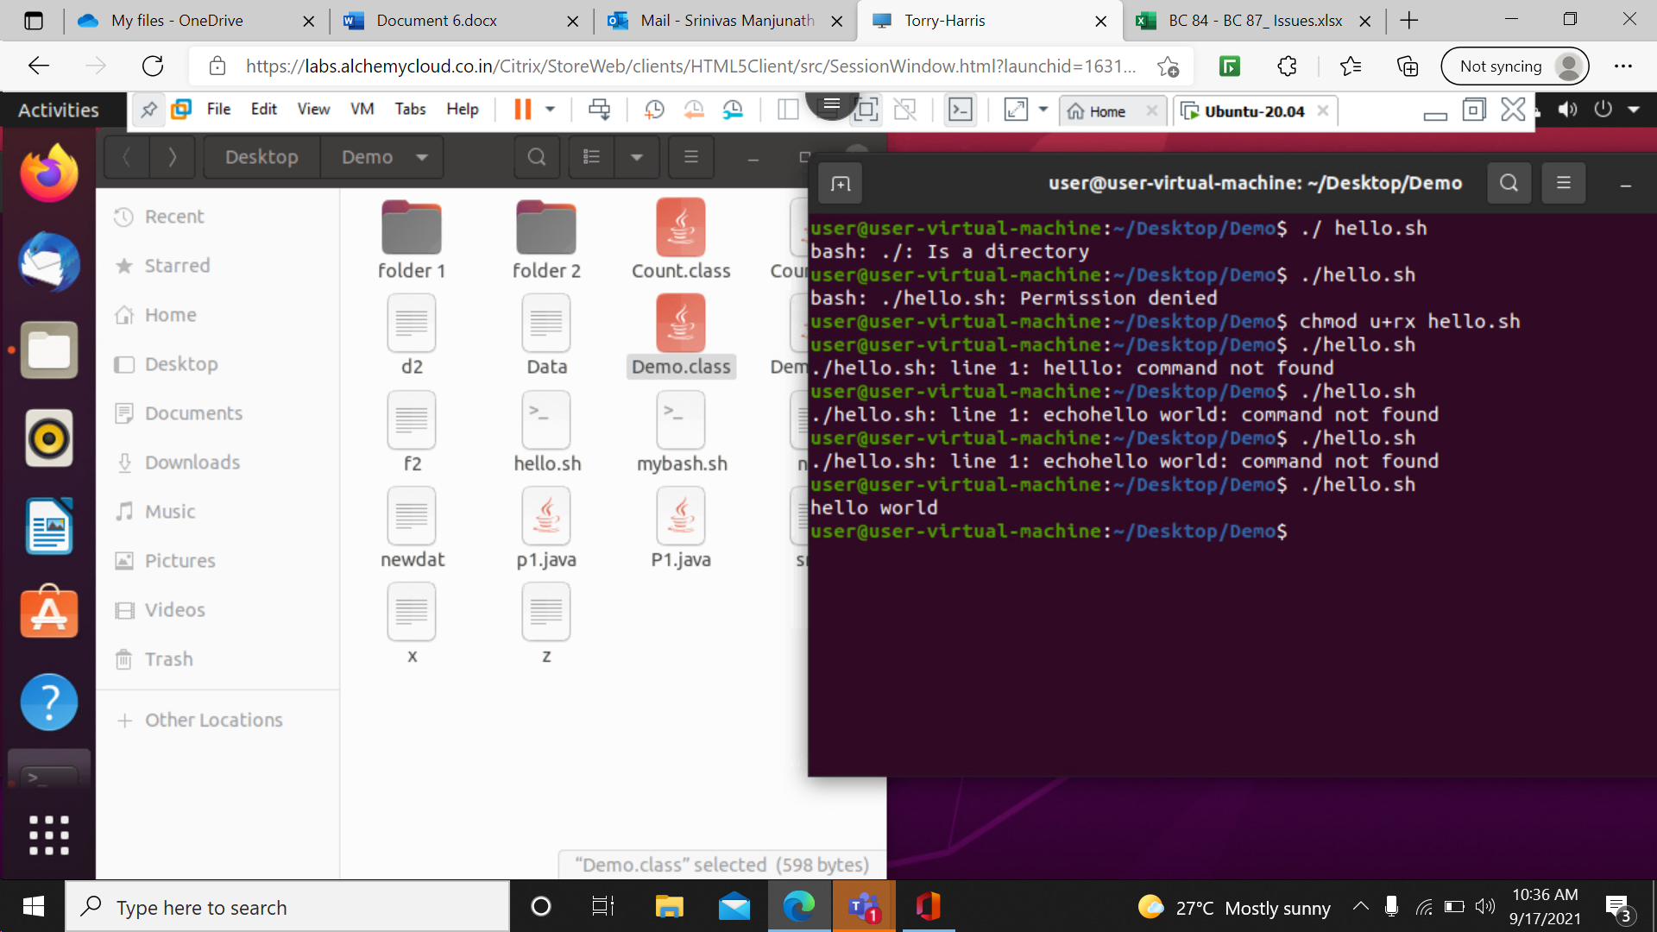

7> chmod is used to give permission to the user to read, write or execute. Or $chmod 777 filename



8> another method of chmod (octal method).

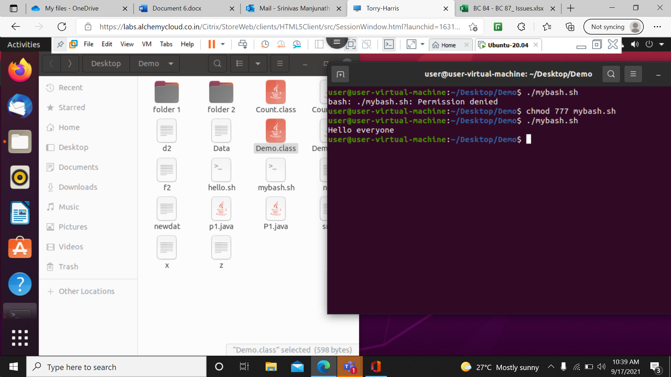

9> chmod for only execution permission.

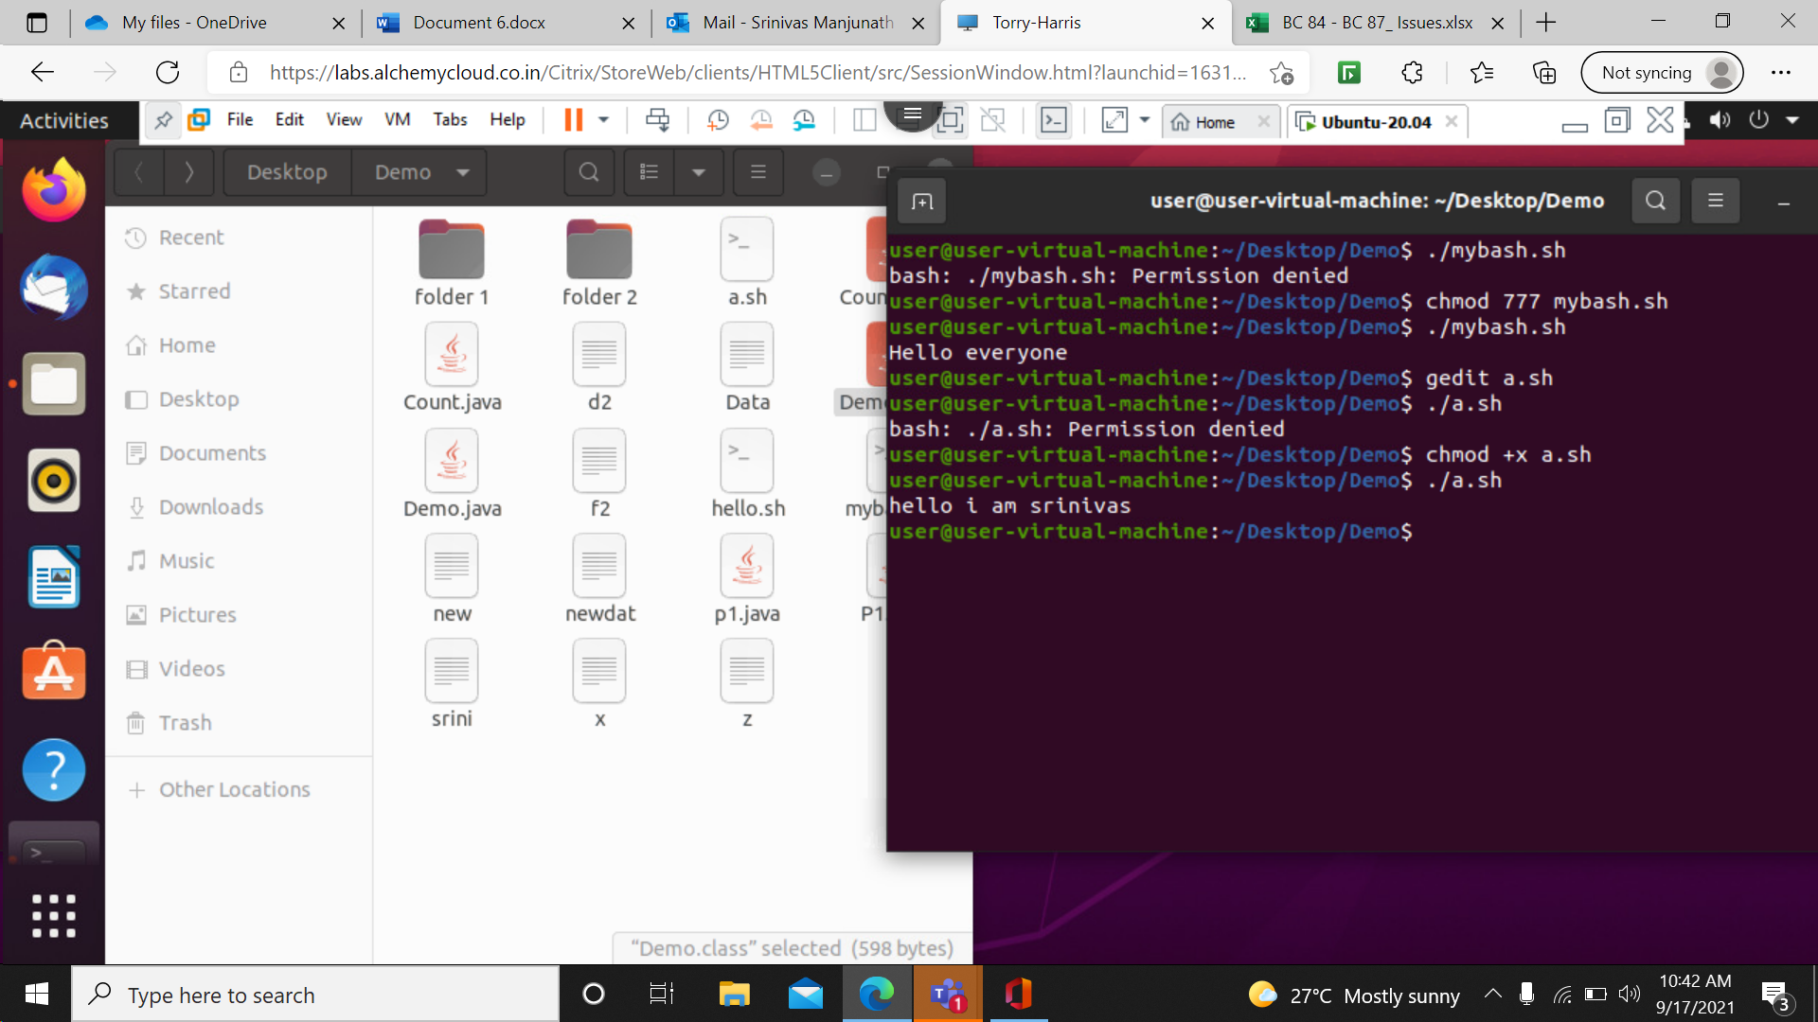

10> using echo we can create a file and write inside it my using $echo ‘Helllo..’> filename.tx

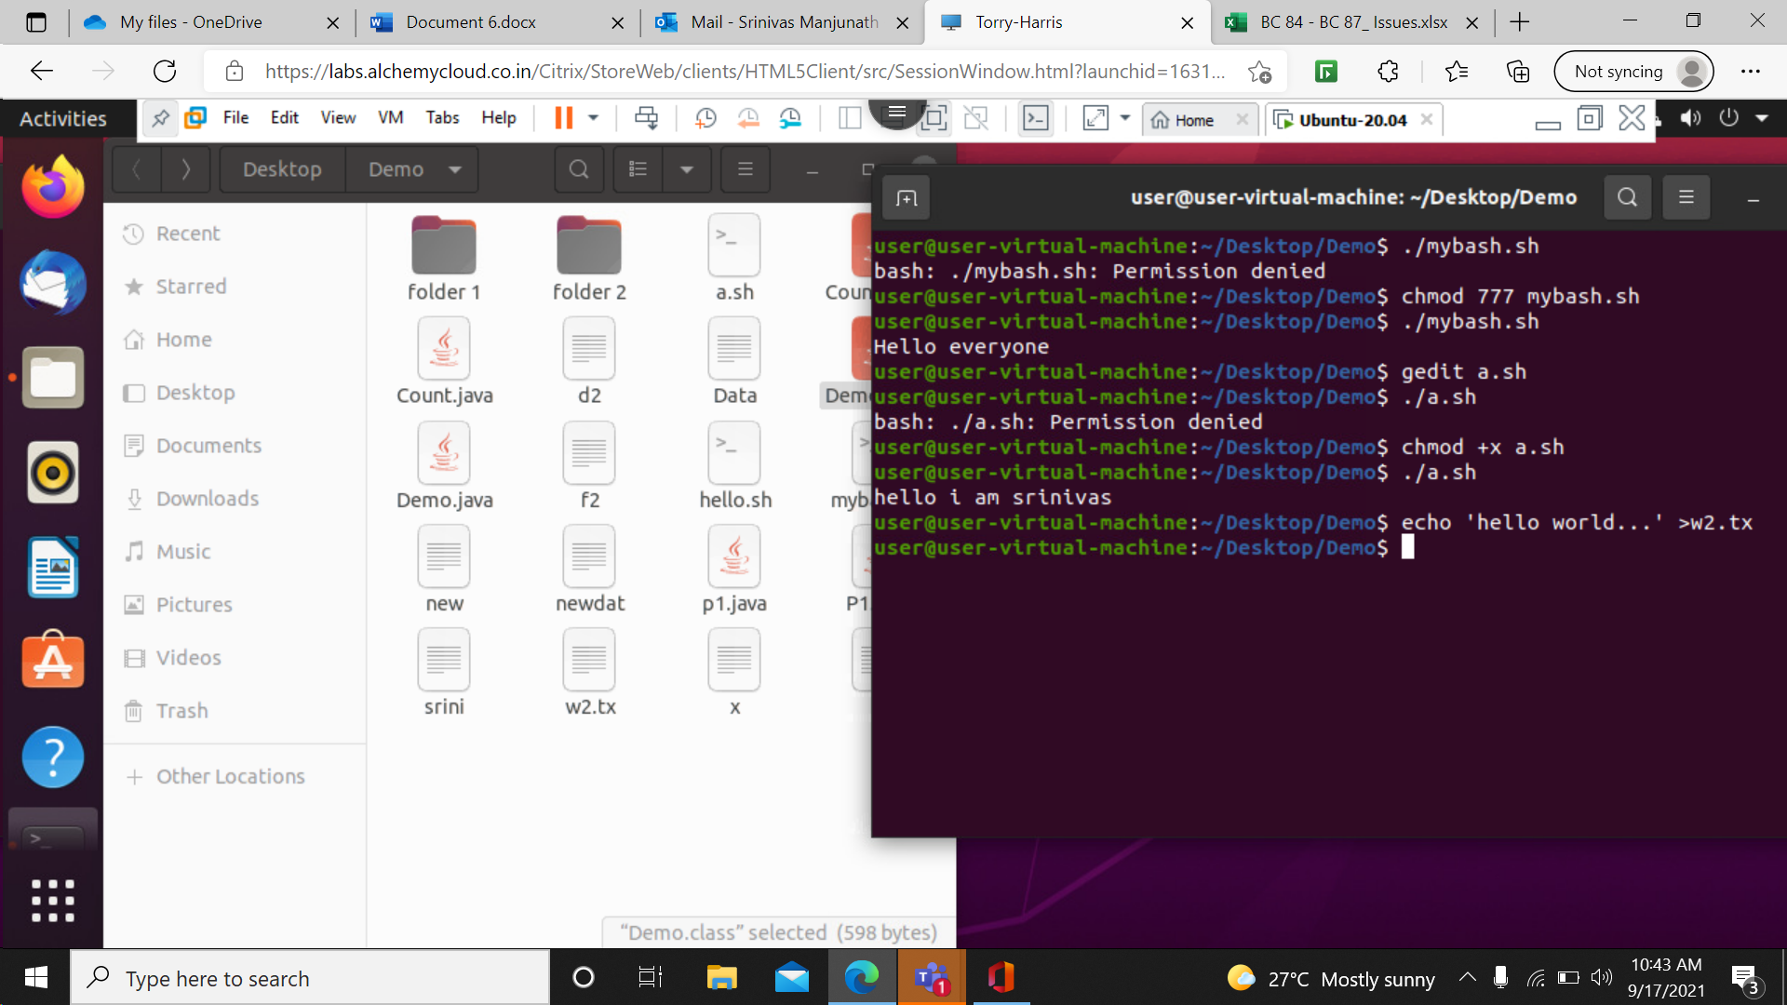

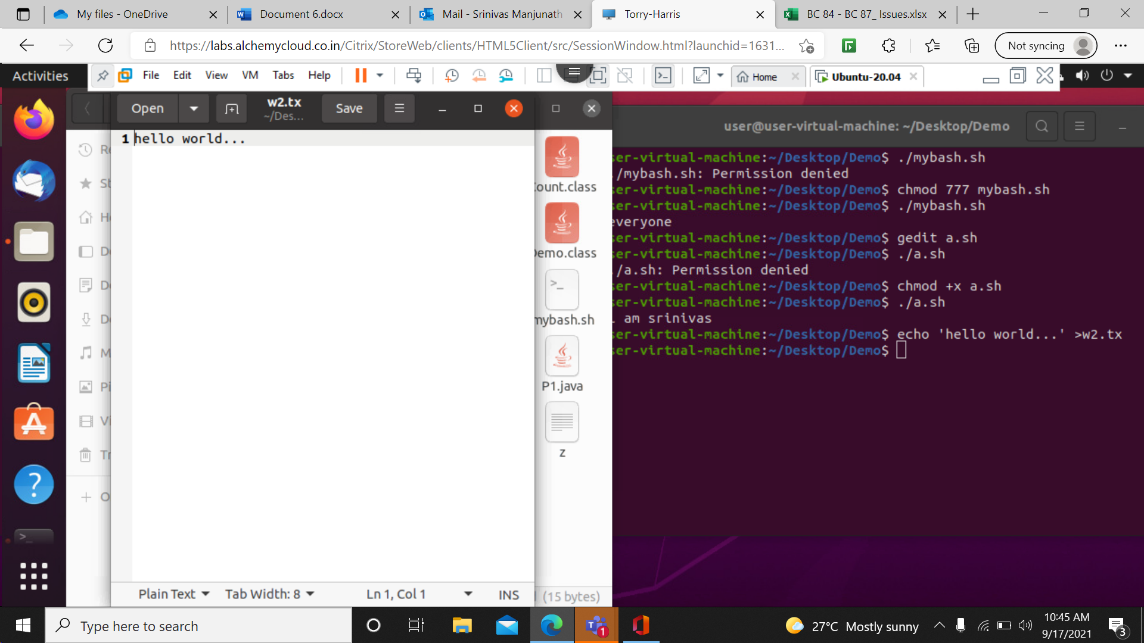

11> creation of new folder using mkdir and creation of file into it using echo.

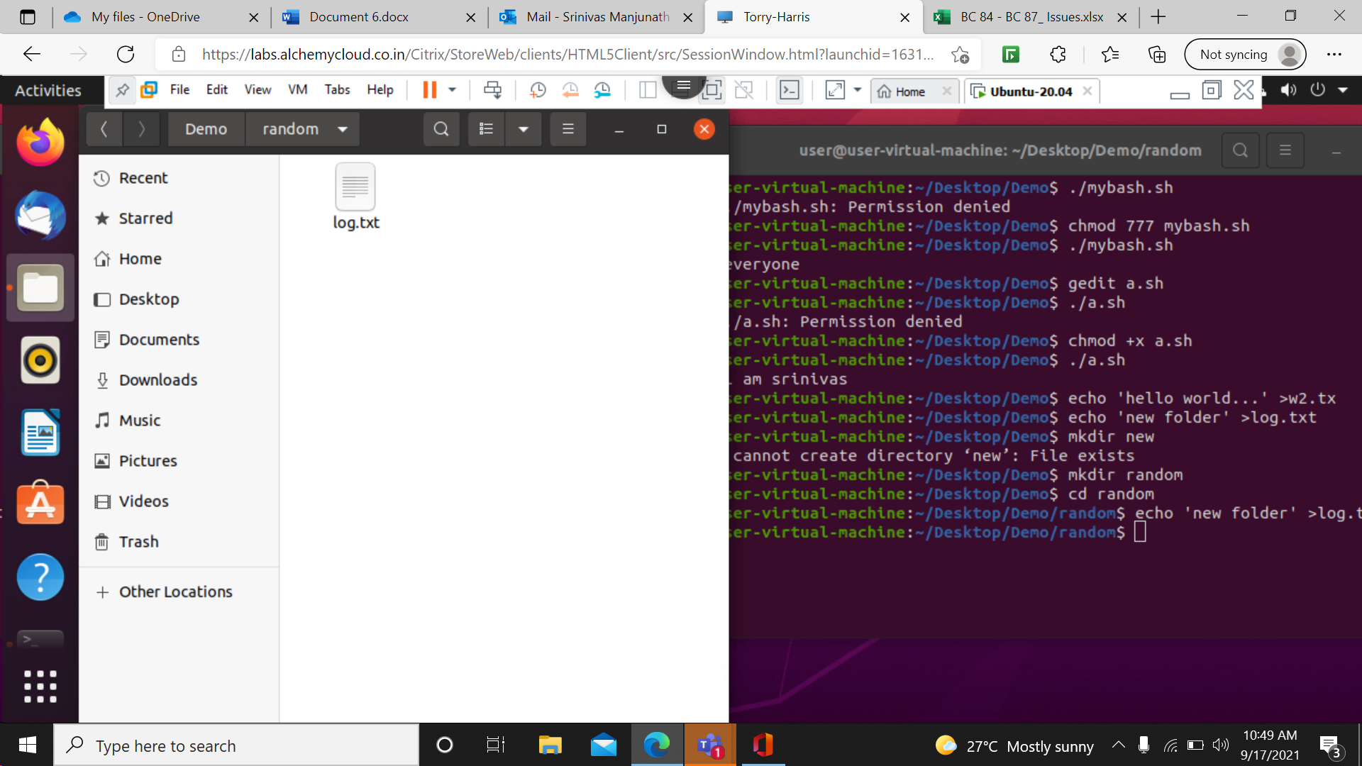

12> Creation of file and execution in Single shell file. First type the code in shell file and then execute it.

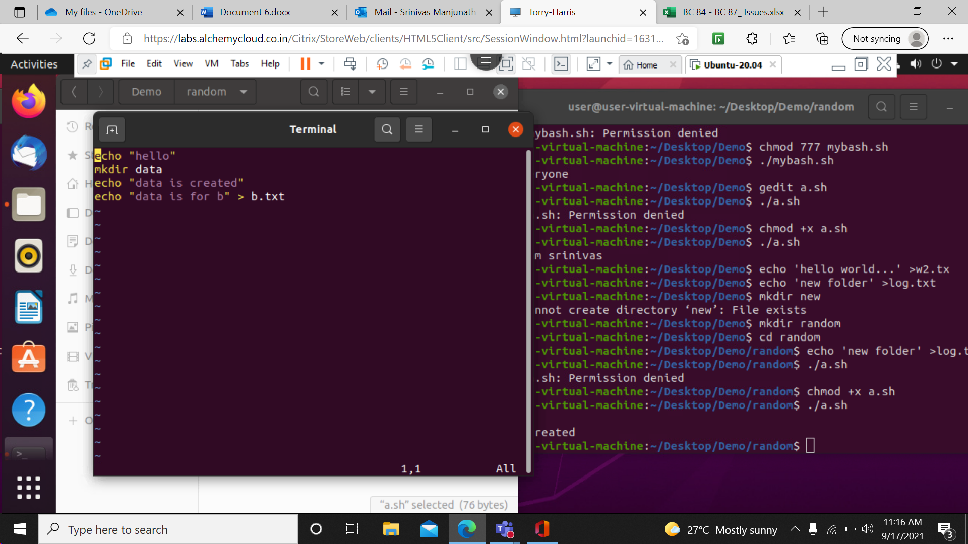

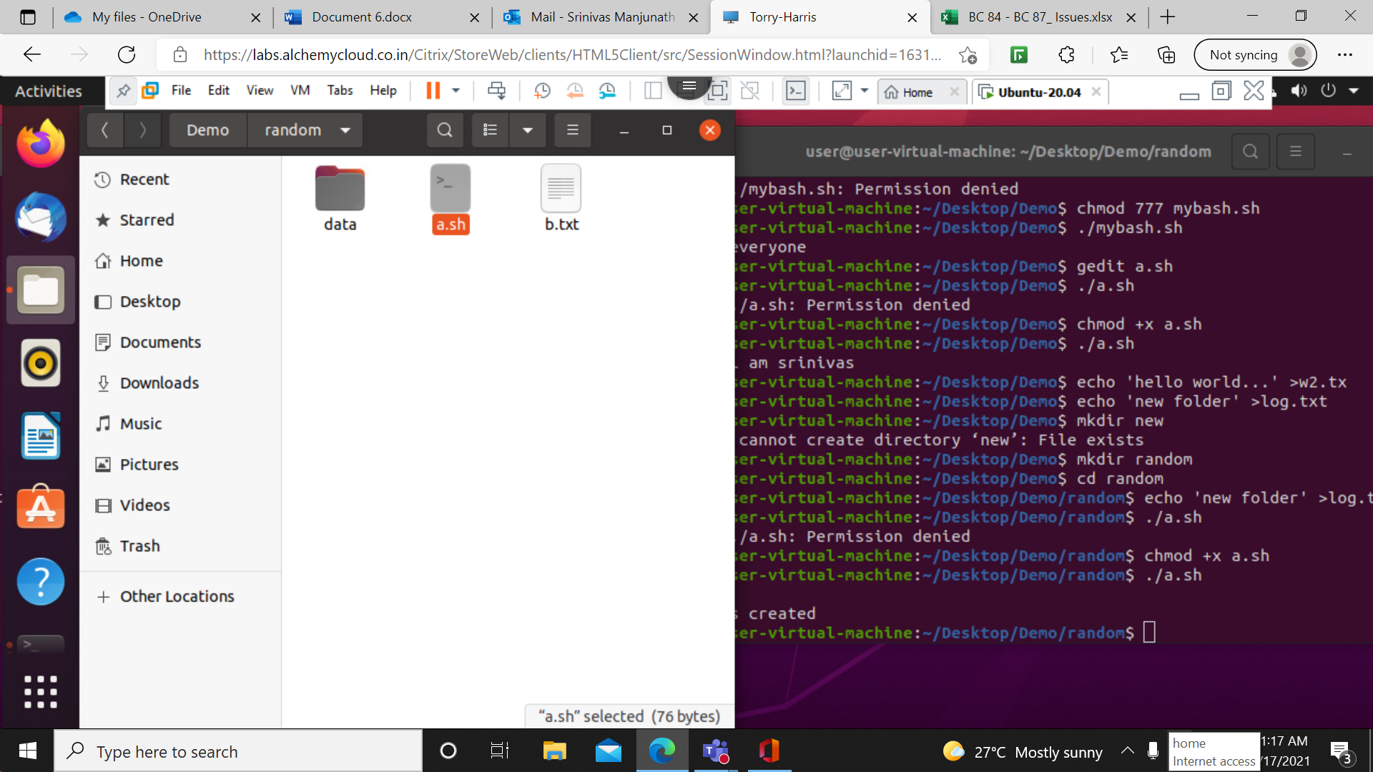

13> printing multiple lines in terminal and printing first three lines in different file by creating the file in echo.

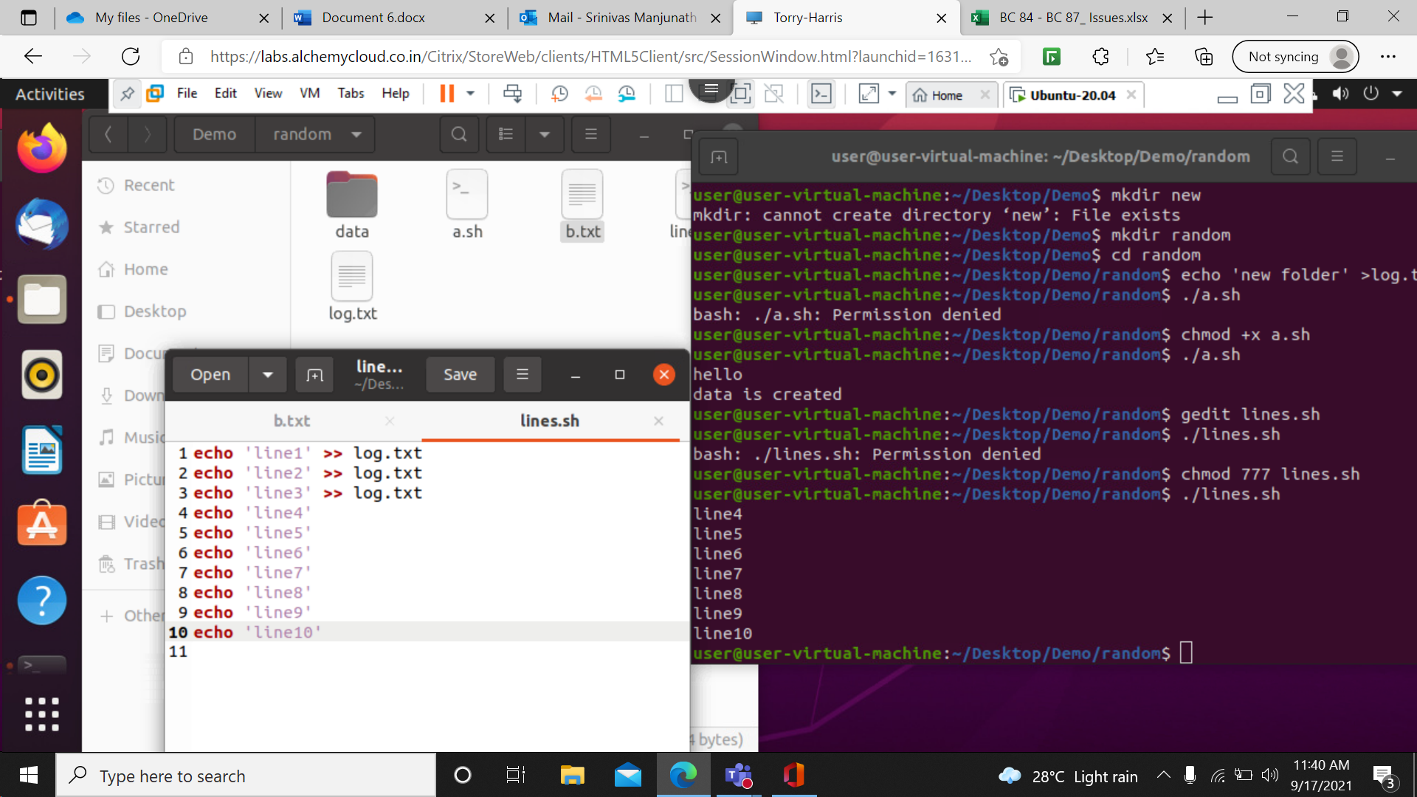

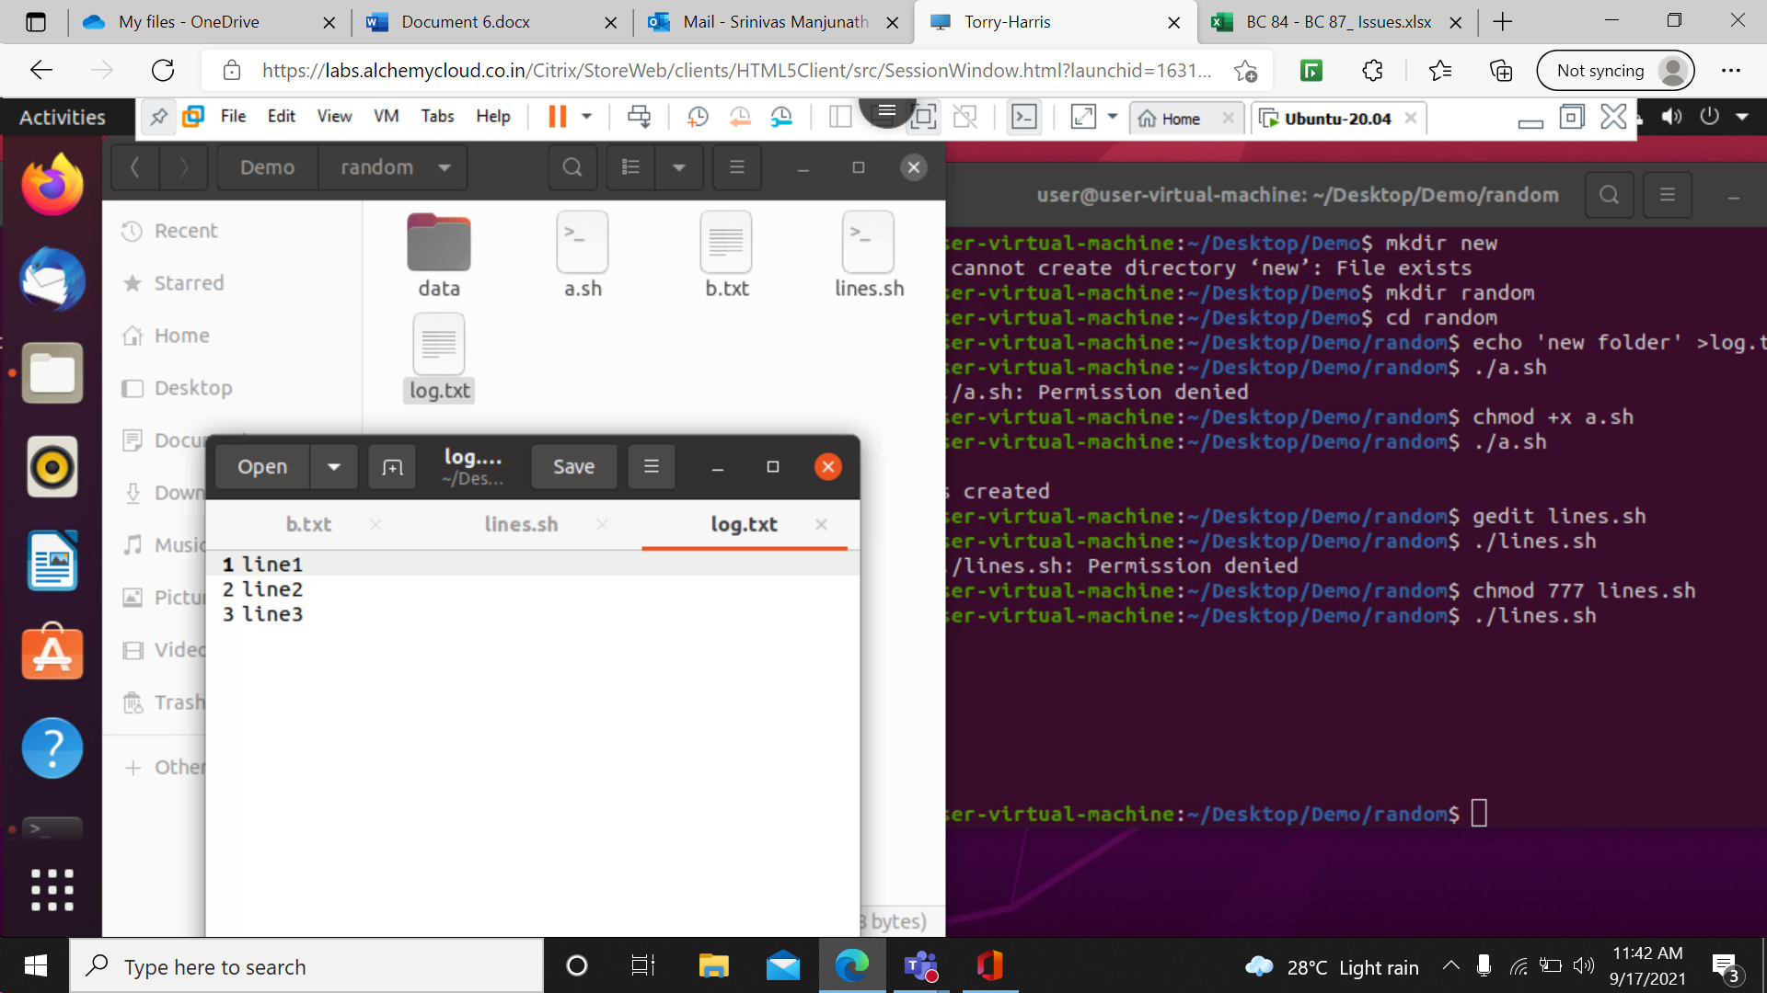

14> To write commands that is single line and multiple line commands in shell.

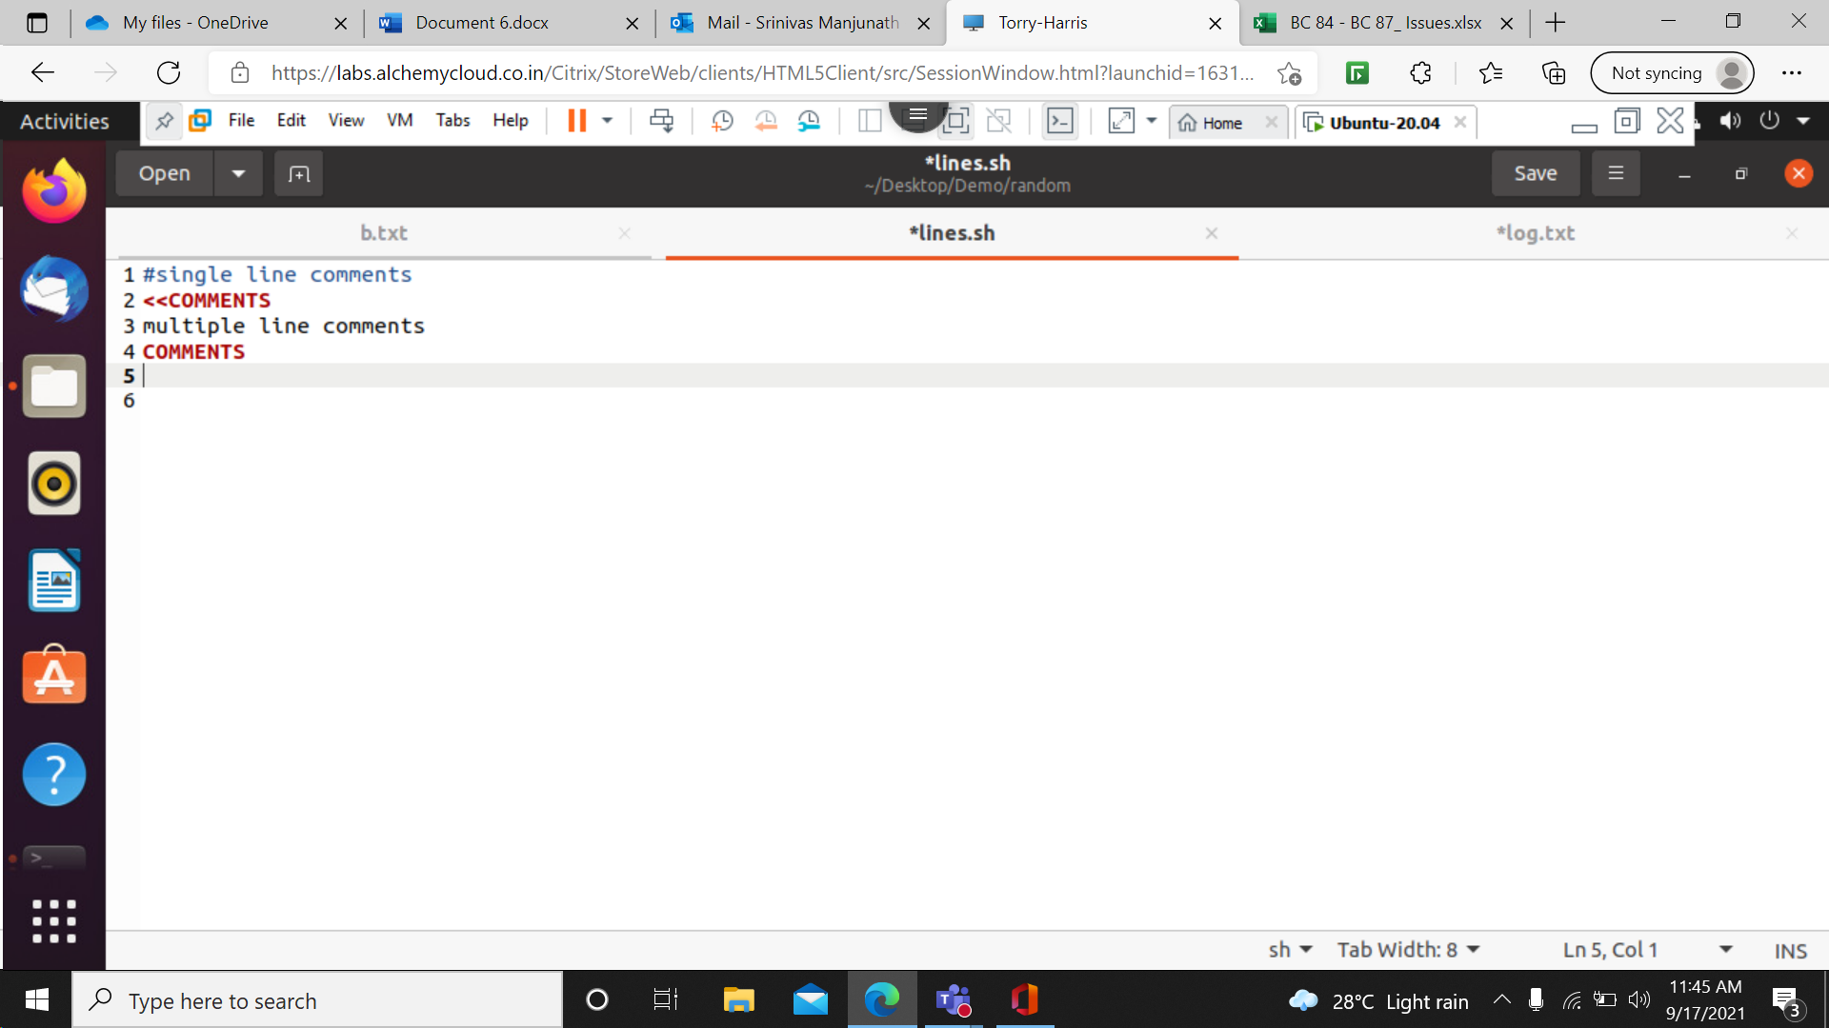

15> How to write variable in shell varname=”hello” (without space) and to print it using echo.

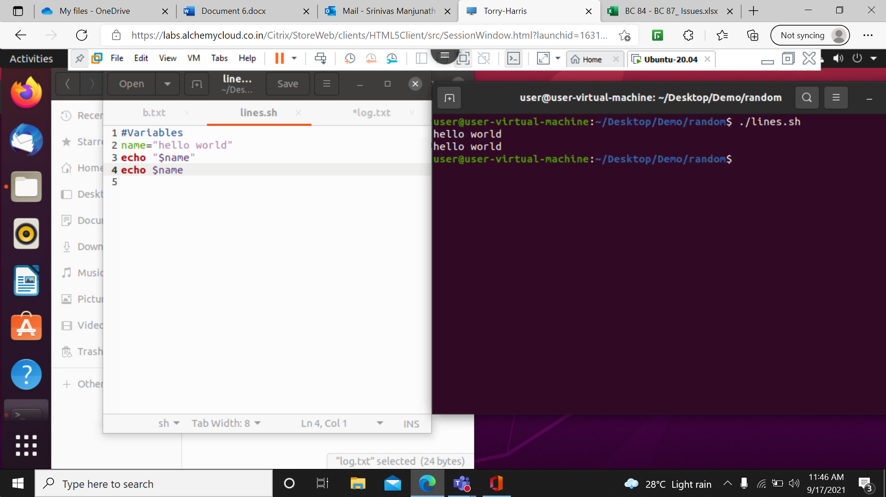

16> write a program to calculate simple interest.

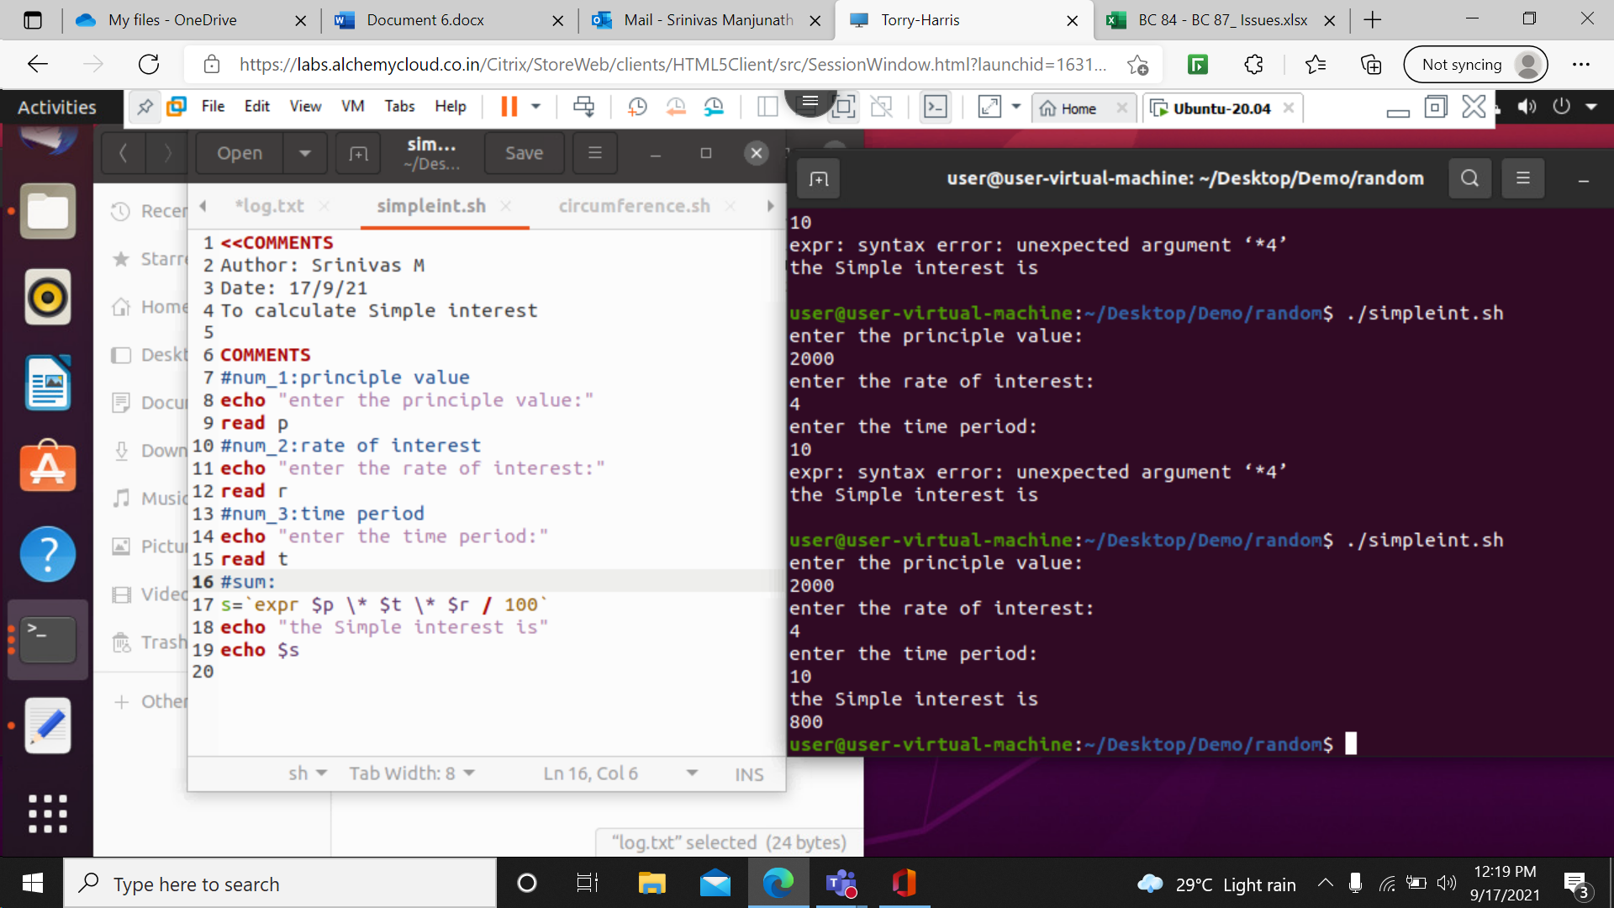

17> write a program to calculate Circumference of a circle.

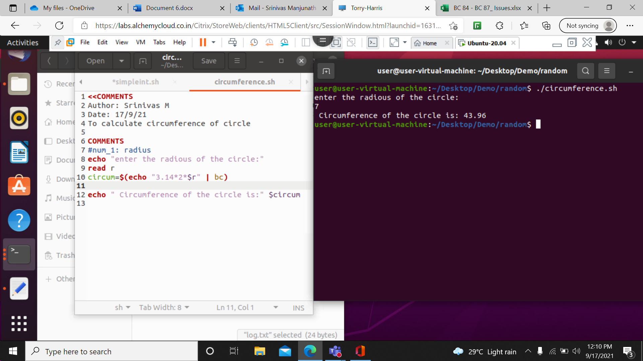

18> write a program to calculate Diagonal of triangle.

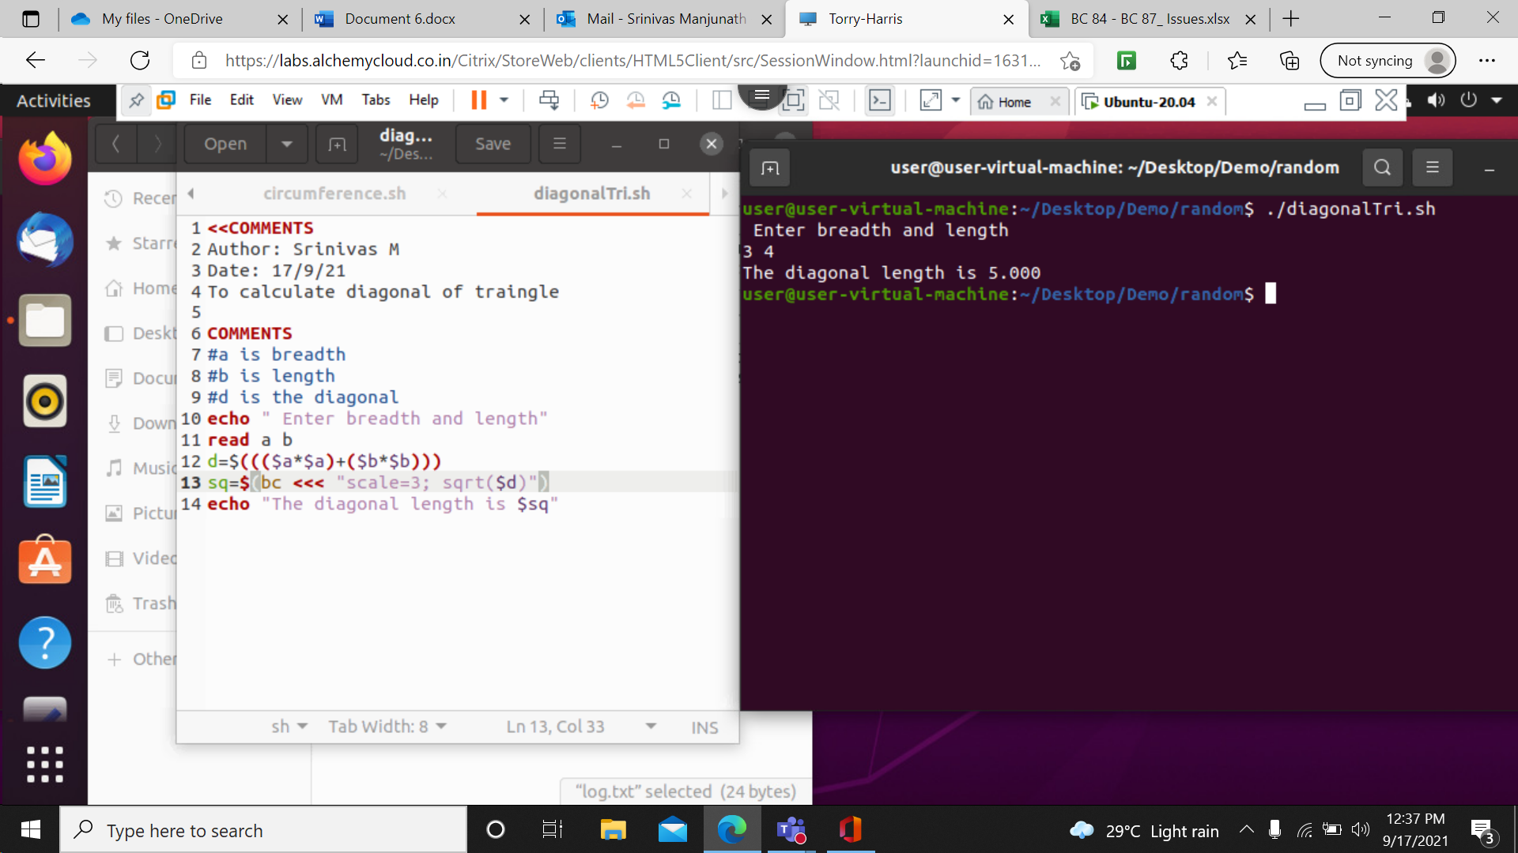

17> To print the table of the number.

Sol: echo ‘enter a number’

read n

while [ $i -le 10 ]

do

echo “ $n x $i = $((n \* i))”

i =$(( i +1))

done

18> Write a program to print a pattern up to nth line

Sol:

rows=4

for((i=1; i<=rows; i++))

do

for((j=1;j<=i;j++))

do

echo –n “\* ”

done

echo

done

19> Write a program to print a patter up to nth number

Sol: rows=5

for((i=1; I>=1; i++))

do

for((j=1;j<=i;j++))

do

echo –n “+i ”

done

echo

done